Moving Head through An Audio Cue

- This function is part of the mechanisms of PTHeadProj. It can be found at: I:\Src\Framework\PTHeadProj
- We will discuss the details of Operation 3 in Mechanism Activate.
- The goal of this function is to calculate θL and θR given a singular pan angle coming from the Sound Agent.
  - I.e. the sound agent can output (given event 2 2, or state 2) an angle from which there is a sound queue in the form of LV RV P T. From these angles, only a pan angle is reported.
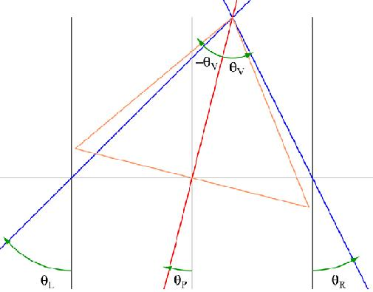

- The θL and θR seen above are the same size wise as those in our cameras but are in opposite sides when compared to our camera head setup. (In the camera setup, the orientation was determined when looking towards the cameras, thus, they are in opposite direction to this diagram).
  - This difference was accounted for in the PTHeadProj code.

- The diagram shows inconsistencies in giving a sign to angles. Our convention will be to consider all counter-clockwise angles as +ve and all clockwise angles as negative.

- The equations used to find θL and θR are the following:

θ_{R} = tan⁻¹ (Cos θ_{V}*Sin θ_{P} + Sinθ_{V}) / (Cosθ_{V}*Cosθ_{P}) (1)
θ_{L} = tan⁻¹ (Cos θ_{V}*Sin θ_{P} - Sinθ_{V}) / (Cosθ_{V}*Cosθ_{P}) (2)

Note:
- Also, verge angles were assumed to be equal to 15˚. (Can also use other angles like 45˚, but the smaller the angle the more direct the camera will move).
- Again, the equation used for θ_{R} was interchanged for θ_{L} as described above.
Experimental Data

We calculated θ_{R} and θ_{L} given different θ_{V}’s and θ_{P}’s to verify the accuracy of the method.

For θ_{V} = 15˚
θ_{P} = -30 | θ_{R} = -15 | θ_{L} = -41.56
θ_{P} = -60 | θ_{R} = -50.1 | θ_{L} = -66.20

For θ_{V} = 45˚
θ_{P} = -30 | θ_{R} = 30 | θ_{L} = -60
θ_{P} = -60 | θ_{R} = 15 | θ_{L} = -75

